The Mentor Toolkit
Contents

First Meeting Tool 2
Template Meeting Tool for Subsequent Meetings 3
Vision Worksheet 4
Strengths Assessment 6
The Logic Tree 7
GROW Model 8

This Toolkit is designed to be used with your Mentee.

It is intended to be printed and handwritten, but you will also be able to use it electronically -- you can use it to record notes from your meetings, and there are useful exercises you may like to do with your Mentee. The GROW model at the end gives you a useful framework of questions to structure your meetings.

First Meeting Tool

Directions:
Use this two-page tool for the first meeting with your mentee (for future meetings use the Meeting Tool).

Background information on your Mentee
Name of Mentee
Best contact address
Tel (BH) |  |  | Tel (AH)
Mobile |  |  | Email
Background (work, education, other):
Mentee needs
Discuss areas/strengths to leverage as well as growth areas to improve. What knowledge, skills, attitude changes, and resources does the mentee need? It is important to reach agreement on some goals in the first couple of sessions, even if the goals change later.
Immediate
Longer term
How we will manage the relationship
Expectations of each other
How often, when and how we’ll “meet”
Ways we’ll communicate
Limits or constraints on our interaction and how we’ll handle those
Challenges we’re likely to face and what we can do to prevent or manage these (discuss how you’ll manage when either of you is travelling for example)
Other agreements
Specific assistance the mentor can provide (keep general at this point)
How we’ll know we’ve been successful
Action items to complete before next meeting
Next meeting date, time, channel

Template Meeting Tool for Subsequent Meetings

Meeting Tool: Meeting 2

Date/Time: |  |  | Channel
Progress made/successes to celebrate
What has happened since the last session? What have you done that you’re proud of? What are you noticing?
Challenges
What obstacles do you see in your path? What do you need to focus on?
Specific goal(s)/topic(s) for this meeting
How can you best support your mentee?
Key things learned from this meeting
Follow-up actions
Mentee
Mentor

Meeting Tool: Meeting 3

Date/Time: |  |  | Channel
Progress made/successes to celebrate
What has happened since the last session? What have you done that you’re proud of? What are you noticing?
Challenges
What obstacles do you see in your path? What do you need to focus on?
Specific goal(s)/topic(s) for this meeting
How can you best support your mentee?
Key things learned from this meeting
Follow-up actions
Mentee
Mentor

Vision Worksheet
Summary of Values and Strengths, with your personal and professional vision
MY DEEPEST VALUES
MY STRENGTHS
Jumping ahead to the end of my life, what are the 3 most important lessons I’ve learned and why are they so critical
When I think of someone I deeply respect, the 3 qualities I most admire are:
What is the one sentence inscription you would like to see on your tombstone that captures who you really were in your life?
Describe yourself when you are at your best
Now write your vision statement in the present tense. It should be practical and deeply inspiring, and reflect the person you most want to be in your personal life and work life.
My personal vision, reflecting my deepest values is:
My work/career vision, reflecting my personal vision and deepest values:
Adapted from Loehr and Schwartz, (2003) The Power of Full Engagement, The Free Press: New York.

Strengths Assessment

Put simply, your strengths are the things you do naturally that energise you and you’re great at. You find them easy.
The list below represents a list of strengths identified by the Centre for Applied Positive Psychology and used in their Realise2 tool.

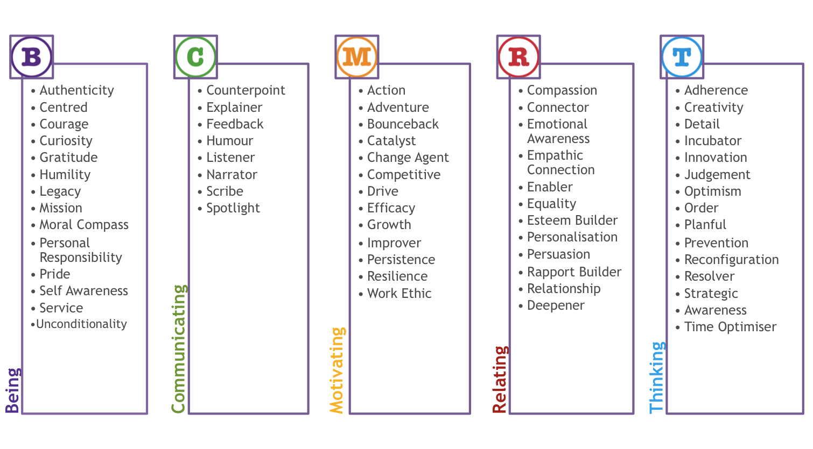
Ref: CAPP, 2012

You can use your own language to describe your strengths, or borrow from this list.
My Top Strengths

The Logic Tree

To clarify how to achieve difficult, complex goals
People often fail to start working towards a goal, because they can’t see a clear path towards it. The Logic tree helps break down a more complex goal into a series of more easily achieved steps. A mentor can help give examples of how they got from A to B – however, this may not always be relevant and the path for the mentee may be different. (For example, because times have changed, they are starting at a different point, and/or they have a different set of skills and personality traits.)
- The starting point of the logic tree is to express the goal in as few words as possible. For example, “I want to become a Mine Planning Manager”.
- Next is to ask the question, “What would have had to happen for you to achieve that?” A number of statements will emerge. In this example, these might include: “Qualify as an accredited director”. “Understudy Mine Planning Manager”, “Gain wider experience across the operations function”, “Build relationships with a specialist head-hunter” and so on.
- For each of these statements, repeat the question “What would have had to happen for you to achieve that?” Keep doing so until you have covered a large sheet of paper (you may need several sheets of flipchart paper fixed together) and have reached the point on each of the roots of the logic tree, where you can label items “Things I can do now”.
- Begin to apply some timelines e.g. by what date do I want to achieve x?
- Step and back and review the process – by now the goal should seem more achievable than before. Has anything been missed?
- Regularly review where the mentee is on the flowchart.

The logic tree provides a practical roadmap for change. In some cases, the mentee’s response to the logic tree is to recognise that they are unwilling to invest the amount of time and energy that will be needed – so they move on to a different goal, which they are more able to commit to.
[Source: Megginson, D. &, Clutterbuck D. (2005) Techniques for Coaching and Mentoring, Elsevier: Oxford]

GROW Model

Useful questions for coaches and mentors

In the GROW model, the client first engages in goal-setting, then explores the current situation and the options available before deciding on whether/her and what actions might be taken.
Goal – what do you want?
Reality – where are you now?
Options – what could you do?
Will – what will you do?

GOAL

What is it you would like to discuss?
What would need to happen for you to walk away feeling that this is time well spent?
What do you want instead of xxxxxx?
Is that realistic?
How do you know this goal is worth achieving?
How will you know when you have achieved it?
What will you see hear feel when you have achieved it?

REALITY

What is happening at the moment?
How do you know this is accurate/true?
When, where, how often does this happen?
Who is involved?
What happens to you and how do you feel?
What happens to others directly involved?
What is their perception of the situation?

OPTIONS

What approaches have you seen in similar situations?
What would you do differently if you were able to start again?
Who might be able to help?
What if you had (more/less time power money magic wand)?
What is the most courageous step to take?
If the constraints were removed, what would you do?

WILL

What are the next steps?
Will this address your goal?
Precisely when will you take them?
What will it cost you if you don’t take action?
What might get in the way?
Who needs to know?
What support do you need and from whom?
On a scale of 1-10 what are you going to do (your motivation)?
What do you need to do to get your commitment up to a 10?

The AWRA e-Mentoring Program is delivered by AMMA, and funded by the Australian Government through the National Resources Sector Workforce Strategy

